Atharva Karkar

8

MCA(DS)

* Write a program that takes a filename as input and checks if it is executable, if not make it executable

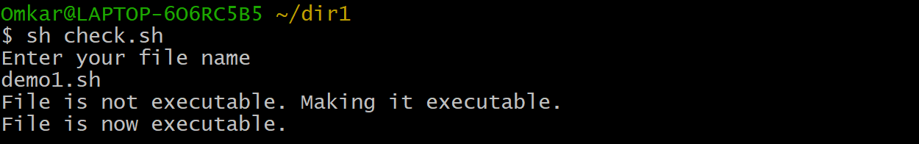

echo "Enter your file name"

read filename

if [ ! -x "$filename" ]; then

echo "File is not executable. Making it executable."

chmod +x "$filename"

echo "File is now executable."

else

echo "File is already executable."

fi